User

Manual

**Version 2.2**

|  |  |
| --- | --- |
| ***Corporate Office*** | ***Offshore Development Center*** |
| *1 Pickering Street*  *#06-03 Great Eastern Centre*  *Singapore 048659* | *Plot # 122 & 123, N.S.E.Z, Phase -2*  *NOIDA, UP 201 305*  *India*  *Tel: 91.11.91.2510483* |

|  |  |  |  |  |
| --- | --- | --- | --- | --- |
| **Author** | | | | |
| **Name** | **Role** | **Date of Preparation** | **Signature** | |
| Varun Gupta | Business Analyst | 30-Jan-2015 | Varun | |
| **Reviewer(s)** | | | | |
| **Name** | **Role** | **Date of Review** | **Signature** | |
| Pravesh Kumar | Manager Projects |  |  | |
|  |  |  |  | |
| **Approver** | | | | |
| **Name** | **Role** | **Date of Approval** | **Signature** | |
| ChengChoon Yip | VP Ebix Exchange  Asia |  |  | |
| **Document Path** | **Version Number** | **Date of Release** | | |
|  |  |  | | |
|  |  |  | | |
| **Revision History** | | | | |
| **Version Number** | **Date of Release** | **Section/ Page # Changed** | | **Details of Changes** |
|  |  |  | |  |
|  |  |  | |  |

|  |  |  |
| --- | --- | --- |
| **References** | | |
| **Document** | **Date Received** | **Author** |
|  |  |  |

Contents

1. Home Screen 16

2. Upload Main Menu 17

2.1 Browse Screen 19

2.1.1 Field Validation 19

2.1.2 Dependencies 19

2.1.4 Outcome 20

2.1.5 Search criteria section 21

2.2 Bus Captain Listing Screen 22

2.2.1 Add Screen 23

2.2.1.1 Screen Description 23

2.2.1.2 Field Validations 23

2.2.1.3 Dependencies 23

2.2.1.4 Outcome 23

2.2.1.5 Messages Handling 23

3. Type of Loss 24

3.1 Search Screen 24

3.1.1 Description 24

3.1.2 Field Validations 24

3.1.3 Dependencies 24

3.1.4 Outcome 25

3.1.5 Message Handling 25

3.2 Add Screen 25

3.2.1 Field Validations 25

3.2.2 Dependencies 25

3.2.3 Outcome 26

3.2.4 Message Handling 26

3.3 Edit Screen 27

3.3.1 Description 27

3.3.2 Field Validations 27

3.3.3 Dependencies 27

3.3.4 Outcome 27

3.3.5 Message Handling 27

3.4 View Screen 28

4. Main Class of Business 28

4.1 Search Screen 28

4.1.1 Description 28

4.1.2 Field Validations 28

4.1.3 Dependencies 28

4.1.4 Outcome 29

4.1.5 Message Handling 29

4.2 Add Screen 30

4.2.1 Description 30

4.2.2 Field Validations 30

4.2.3 Dependencies 30

4.2.4 Outcome 30

4.2.5 Message Handling 30

4.3 Edit Screen 31

5. Sub-Class 31

5.1 Search Screen 31

5.1.1 Description 31

5.1.2 Field Validations 31

5.1.3 Dependencies 31

5.1.4 Outcome 31

5.1.5 Message Handling 31

5.2 Add Screen 31

5.2.1 Description 32

5.2.2 Field Validations 32

5.2.3 Dependencies 32

5.2.4 Outcome 32

5.2.5 Message Handling 32

5.3 Edit Screen 32

5.3.1 Description 32

5.3.2 Field Validations 32

5.3.3 Dependencies 32

5.3.4 Outcome 32

5.3.5 Message Handling 32

6. Claim expense master 32

6.1 Search Screen 32

6.1.1 Description 32

6.1.2 Field Validations 32

6.1.3 Dependencies 32

6.1.4 Outcome 32

6.1.5 Message Handling 32

6.2 Add Screen 32

6.2.1 Description 33

6.2.2 Field Validations 33

6.2.3 Dependencies 33

6.2.4 Outcome 33

6.2.5 Message Handling 33

6.3 Edit Screen 33

6.3.1 Description 33

6.3.2 Field Validations 33

6.3.3 Dependencies 33

6.3.4 Outcome 33

6.3.5 Message Handling 33

7. Claim Close Reason Master 33

7.1 Search Screen 33

7.1.1 Description 33

7.1.2 Field Validations 33

7.1.3 Dependencies 33

7.1.4 Outcome 33

7.1.5 Message Handling 33

7.2 Add Screen 33

7.2.1 Description 34

7.2.2 Field Validations 34

7.2.3 Dependencies 34

7.2.4 Outcome 34

7.2.5 Message Handling 34

7.3 Edit Screen 34

7.3.1 Description 34

7.3.2 Field Validations 34

7.3.3 Dependencies 34

7.3.4 Outcome 34

7.3.5 Message Handling 34

8. Currency Master 34

8.1 Search Screen 34

8.1.1 Description 34

8.1.2 Field Validations 34

8.1.3 Dependencies 34

8.1.4 Outcome 34

8.1.5 Message Handling 34

8.2 Add Screen 34

8.2.1 Description 35

8.2.2 Field Validations 35

8.2.3 Dependencies 35

8.2.4 Outcome 35

8.2.5 Message Handling 35

8.3 Edit Screen 35

8.3.1 Description 35

8.3.2 Field Validations 35

8.3.3 Dependencies 35

8.3.4 Outcome 35

8.3.5 Message Handling 35

9. Exchange Rate Master 35

9.1 Search Screen 35

9.1.1 Description 35

9.1.2 Field Validations 35

9.1.3 Dependencies 35

9.1.4 Outcome 35

9.1.5 Message Handling 35

9.2 Add Screen 35

9.2.1 Description 36

9.2.2 Field Validations 36

9.2.3 Dependencies 36

9.2.4 Outcome 36

9.2.5 Message Handling 36

9.3 Edit Screen 36

9.3.1 Description 36

9.3.2 Field Validations 36

9.3.3 Dependencies 36

9.3.4 Outcome 36

9.3.5 Message Handling 36

10. User Admin 36

10.1 Entity Details 36

10.1.1 Search Screen 36

10.1.1.1 Description 36

10.1.1.2 Field Validations 36

10.1.1.3 Dependencies 36

10.1.1.4 Outcome 36

10.1.1.5 Message Handling 36

10.1.2 Add Screen 37

10.1.2.1 Description 37

10.1.2.2 Field Validations 37

10.1.2.3 Dependencies 37

10.1.2.4 Outcome 37

10.1.2.5 Message Handling 37

10.1.3 Edit Screen 37

10.1.3.1 Description 37

10.1.3.2 Field Validations 37

10.1.3.3 Dependencies 37

10.1.3.4 Outcome 37

10.1.3.5 Message Handling 37

10.2 User Group 37

10.2.1 Search Screen 37

10.2.1.1 Description 38

10.2.1.2 Field Validations 38

10.2.1.3 Dependencies 38

10.2.1.4 Outcome 38

10.2.1.5 Message Handling 38

10.2.2 Add Screen 38

10.2.2.1 Description 38

10.2.2.2 Field Validations 38

10.2.2.3 Dependencies 38

10.2.2.4 Outcome 38

10.2.2.5 Message Handling 38

10.2.3 Edit Screen 39

10.2.3.1 Description 39

10.2.3.2 Field Validations 39

10.2.3.3 Dependencies 39

10.2.3.4 Outcome 39

10.2.3.5 Message Handling 39

10.2.4 Select Permission List Screen 39

10.2.4.1 Description 39

10.2.4.2 Field Validations 39

10.2.4.3 Dependencies 39

10.2.4.4 Outcome 39

10.2.4.5 Message Handling 39

10.3 User Screen 40

10.3.1 Search Screen 40

10.3.1.1 Description 40

10.3.1.2 Field Validations 40

10.3.1.3 Dependencies 40

10.3.1.4 Outcome 40

10.3.1.5 Message Handling 40

10.3.2 Add Screen 40

10.3.2.1 Description 40

10.3.2.2 Field Validations 40

10.3.2.3 Dependencies 40

10.3.2.4 Outcome 40

10.3.2.5 Message Handling 40

10.3.3 Edit Screen 41

10.3.3.1 Description 41

10.3.3.2 Field Validations 41

10.3.3.3 Dependencies 41

10.3.3.4 Outcome 41

10.3.3.5 Message Handling 41

10.3.4 Organization Access 41

10.3.4.1 Description 41

10.3.4.2 Field Validations 41

10.3.4.3 Dependencies 41

10.3.4.4 Outcome 41

10.3.4.5 Message Handling 41

10.3.5 FAL Access to User 42

10.3.5.1 Description 42

10.3.5.2 Field Validations 42

10.3.5.3 Dependencies 42

10.3.5.4 Outcome 42

10.3.5.5 Message Handling 42

10.4 Department master 42

10.4.1 Search Screen 42

10.4.1.1 Description 42

10.4.1.2 Field Validations 43

10.4.1.3 Dependencies 43

10.4.1.4 Outcome 43

10.4.1.5 Message Handling 43

10.4.2 Add Screen 43

10.4.2.1 Description 43

10.4.2.2 Field Validations 43

10.4.2.3 Dependencies 43

10.4.2.4 Outcome 43

10.4.2.5 Message Handling 43

10.4.3 Edit Screen 43

10.4.3.1 Description 44

10.4.3.2 Field Validations 44

10.4.3.3 Dependencies 44

10.4.3.4 Outcome 44

10.4.3.5 Message Handling 44

10.5 Password Setup 44

10.5.1 Main Screen 44

10.5.1.1 Description 45

10.5.1.2 Field Validations 45

10.5.1.3 Dependencies 45

10.5.1.4 Outcome 45

10.5.1.5 Message Handling 45

10.6 Released Locked User 45

10.7 Country For User Access 45

11. Country Master 45

11.1 Search Screen 45

11.1.1 Description 45

11.1.2 Field Validations 45

11.1.3 Dependencies 45

11.1.4 Outcome 45

11.1.5 Message Handling 45

11.2 Add Screen 45

11.2.1 Description 46

11.2.2 Field Validations 46

11.2.3 Dependencies 46

11.2.4 Outcome 46

11.2.5 Message Handling 46

11.3 Edit Screen 46

11.3.1 Description 46

11.3.2 Field Validations 46

11.3.3 Dependencies 46

11.3.4 Outcome 46

11.3.5 Message Handling 46

12. Vehicle Class 46

12.1 Search Screen 46

12.1.1 Description 46

12.1.2 Field Validations 46

12.1.3 Dependencies 46

12.1.4 Outcome 46

12.1.5 Message Handling 46

12.2 Add Screen 46

12.2.1 Description 47

12.2.2 Field Validations 47

12.2.3 Dependencies 47

12.2.4 Outcome 47

12.2.5 Message Handling 47

12.3 Edit Screen 47

12.3.1 Description 47

12.3.2 Field Validations 47

12.3.3 Dependencies 47

12.3.4 Outcome 47

12.3.5 Message Handling 47

13. Vehicle Make 47

13.1 Search Screen 47

13.1.1 Description 48

13.1.2 Field Validations 48

13.1.3 Dependencies 48

13.1.4 Outcome 48

13.1.5 Message Handling 48

13.2 Add Screen 48

13.2.1 Description 48

13.2.2 Field Validations 48

13.2.3 Dependencies 48

13.2.4 Outcome 48

13.2.5 Message Handling 48

13.3 Edit Screen 48

13.3.1 Description 48

13.3.2 Field Validations 48

13.3.3 Dependencies 48

13.3.4 Outcome 48

13.3.5 Message Handling 48

14. Vehicle Model 48

14.1 Search Screen 48

14.1.1 Description 49

14.1.2 Field Validations 49

14.1.3 Dependencies 49

14.1.4 Outcome 49

14.1.5 Message Handling 49

14.2 Add Screen 49

14.2.1 Description 49

14.2.2 Field Validations 49

14.2.3 Dependencies 49

14.2.4 Outcome 49

14.2.5 Message Handling 49

14.3 Edit Screen 49

14.3.1 Description 49

14.3.2 Field Validations 49

14.3.3 Dependencies 49

14.3.4 Outcome 49

14.3.5 Message Handling 49

15. Insurance Policy 50

15.1 Search Screen 50

15.1.1 Description 50

15.1.2 Field Validations 50

15.1.3 Dependencies 50

15.1.4 Outcome 50

15.1.5 Message Handling 50

15.2 Add Screen 50

15.2.1 Description 50

15.2.2 Field Validations 50

15.2.3 Dependencies 50

15.2.4 Outcome 50

15.2.5 Message Handling 50

15.3 Edit Screen 50

15.3.1 Description 50

15.3.2 Field Validations 50

15.3.3 Dependencies 50

15.3.4 Outcome 50

15.3.5 Message Handling 50

16. GST Setting 51

16.1 Search Screen 51

16.1.1 Description 51

16.1.2 Field Validations 51

16.1.3 Dependencies 51

16.1.4 Outcome 51

16.1.5 Message Handling 51

16.2 Add Screen 51

16.2.1 Description 51

16.2.2 Field Validations 51

16.2.3 Dependencies 51

16.2.4 Outcome 51

16.2.5 Message Handling 51

16.3 Edit Screen 51

16.3.1 Description 51

16.3.2 Field Validations 51

16.3.3 Dependencies 51

16.3.4 Outcome 51

16.3.5 Message Handling 51

17. Organization 52

17.1 Search Screen 52

17.1.1 Description 52

17.1.2 Field Validations 52

17.1.3 Dependencies 52

17.1.4 Outcome 52

17.1.5 Message Handling 52

17.2 Add Screen 52

17.2.1 Description 53

17.2.2 Field Validations 53

17.2.3 Dependencies 53

17.2.4 Outcome 53

17.2.5 Message Handling 53

17.3 Edit Screen 53

17.3.1 Description 54

17.3.2 Field Validations 54

17.3.3 Dependencies 54

17.3.4 Outcome 54

17.3.5 Message Handling 54

18. Claim Officer Duty 54

18.1 Search Screen 54

18.1.1 Description 54

18.1.2 Field Validations 54

18.1.3 Dependencies 54

18.1.4 Outcome 54

18.1.5 Message Handling 54

18.2 Add Screen 54

18.2.1 Description 55

18.2.2 Field Validations 55

18.2.3 Dependencies 55

18.2.4 Outcome 55

18.2.5 Message Handling 55

18.3 Edit Screen 55

18.3.1 Description 55

18.3.2 Field Validations 55

18.3.3 Dependencies 55

18.3.4 Outcome 55

18.3.5 Message Handling 55

19. LOU Rate 55

19.1 Search Screen 55

19.1.1 Description 55

19.1.2 Field Validations 55

19.1.3 Dependencies 55

19.1.4 Outcome 55

19.1.5 Message Handling 55

19.2 Add Screen 55

19.2.1 Description 56

19.2.2 Field Validations 56

19.2.3 Dependencies 56

19.2.4 Outcome 56

19.2.5 Message Handling 56

19.3 Edit Screen 56

19.3.1 Description 56

19.3.2 Field Validations 56

19.3.3 Dependencies 56

19.3.4 Outcome 56

19.3.5 Message Handling 56

20. Service Provider Master 56

20.1 Insurer Master 56

20.1.1 Search Screen 56

20.1.1.1 Description 56

20.1.1.2 Field Validations 57

20.1.1.3 Dependencies 57

20.1.1.4 Outcome 57

20.1.1.5 Message Handling 57

20.1.2 Add Screen 57

20.1.2.1 Description 57

20.1.2.2 Field Validations 57

20.1.2.3 Dependencies 57

20.1.2.4 Outcome 57

20.1.2.5 Message Handling 57

20.1.3 Edit Screen 58

20.1.3.1 Description 58

20.1.3.2 Field Validations 58

20.1.3.3 Dependencies 58

20.1.3.4 Outcome 58

20.1.3.5 Message Handling 58

20.2 Surveyor Master 58

20.2.1 Search Screen 58

20.2.1.1 Description 58

20.2.1.2 Field Validations 58

20.2.1.3 Dependencies 58

20.2.1.4 Outcome 58

20.2.1.5 Message Handling 58

20.2.2 Add Screen 58

20.2.2.1 Description 59

20.2.2.2 Field Validations 59

20.2.2.3 Dependencies 59

20.2.2.4 Outcome 59

20.2.2.5 Message Handling 59

20.2.3 Edit Screen 59

20.2.3.1 Description 59

20.2.3.2 Field Validations 59

20.2.3.3 Dependencies 59

20.2.3.4 Outcome 59

20.2.3.5 Message Handling 59

20.3 Lawyer Master Screen 60

20.3.1 Search Screen 60

20.3.1.1 Description 60

20.3.1.2 Field Validations 60

20.3.1.3 Dependencies 60

20.3.1.4 Outcome 60

20.3.1.5 Message Handling 60

20.3.2 Add Screen 60

20.3.2.1 Description 60

20.3.2.2 Field Validations 61

20.3.2.3 Dependencies 61

20.3.2.4 Outcome 61

20.3.2.5 Message Handling 61

20.3.3 Edit Screen 61

20.3.3.1 Description 61

20.3.3.2 Field Validations 61

20.3.3.3 Dependencies 61

20.3.3.4 Outcome 61

20.3.3.5 Message Handling 61

20.4 Workshop/Depot Master 62

20.4.1 Search Screen 62

20.4.1.1 Description 62

20.4.1.2 Field Validations 62

20.4.1.3 Dependencies 62

20.4.1.4 Outcome 62

20.4.1.5 Message Handling 62

20.4.2 Add Screen 63

20.4.2.1 Description 63

20.4.2.2 Field Validations 64

20.4.2.3 Dependencies 64

20.4.2.4 Outcome 64

20.4.2.5 Message Handling 64

20.4.3 Edit Screen 64

20.4.3.1 Description 64

20.4.3.2 Field Validations 64

20.4.3.3 Dependencies 64

20.4.3.4 Outcome 64

20.4.3.5 Message Handling 64

20.5 Hospital Master 64

20.5.1 Search Screen 64

20.5.1.1 Description 65

20.5.1.2 Field Validations 65

20.5.1.3 Dependencies 65

20.5.1.4 Outcome 65

20.5.1.5 Message Handling 65

20.5.2 Add Screen 65

20.5.2.1 Description 65

20.5.2.2 Field Validations 66

20.5.2.3 Dependencies 66

20.5.2.4 Outcome 66

20.5.2.5 Message Handling 66

20.5.3 Edit Screen 66

20.5.3.1 Description 67

20.5.3.2 Field Validations 67

20.5.3.3 Dependencies 67

20.5.3.4 Outcome 67

20.5.3.5 Message Handling 67

20.6 Adjuster Master 67

20.6.1 Search Screen 67

20.6.1.1 Description 68

20.6.1.2 Field Validations 68

20.6.1.3 Dependencies 68

20.6.1.4 Outcome 68

20.6.1.5 Message Handling 68

20.6.2 Add Screen 68

20.6.2.1 Description 68

20.6.2.2 Field Validations 69

20.6.2.3 Dependencies 69

20.6.2.4 Outcome 69

20.6.2.5 Message Handling 69

20.6.3 Edit Screen 69

20.6.3.1 Description 69

20.6.3.2 Field Validations 69

20.6.3.3 Dependencies 69

20.6.3.4 Outcome 69

20.6.3.5 Message Handling 69

21. Interchange Master Screen 69

21.1 Search Screen 70

21.1.1 Description 70

21.1.2 Field Validations 70

21.1.3 Dependencies 70

21.1.4 Outcome 70

21.1.5 Message Handling 70

21.2 Add Screen 70

21.2.1 Description 70

21.2.2 Field Validations 70

21.2.3 Dependencies 70

21.2.4 Outcome 70

21.2.5 Message Handling 70

21.3 Edit Screen 70

21.3.1 Description 70

21.3.2 Field Validations 70

21.3.3 Dependencies 70

21.3.4 Outcome 70

21.3.5 Message Handling 70

22. Deductible Master 71

22.1 Search Screen 71

22.1.1 Description 71

22.1.2 Field Validations 71

22.1.3 Dependencies 71

22.1.4 Outcome 71

22.1.5 Message Handling 71

22.2 Add Screen 71

22.2.1 Description 72

22.2.2 Field Validations 72

22.2.3 Dependencies 72

22.2.4 Outcome 72

22.2.5 Message Handling 72

22.3 Edit Screen 72

22.3.1 Description 72

22.3.2 Field Validations 72

22.3.3 Dependencies 72

22.3.4 Outcome 72

22.3.5 Message Handling 72

# Home Screen

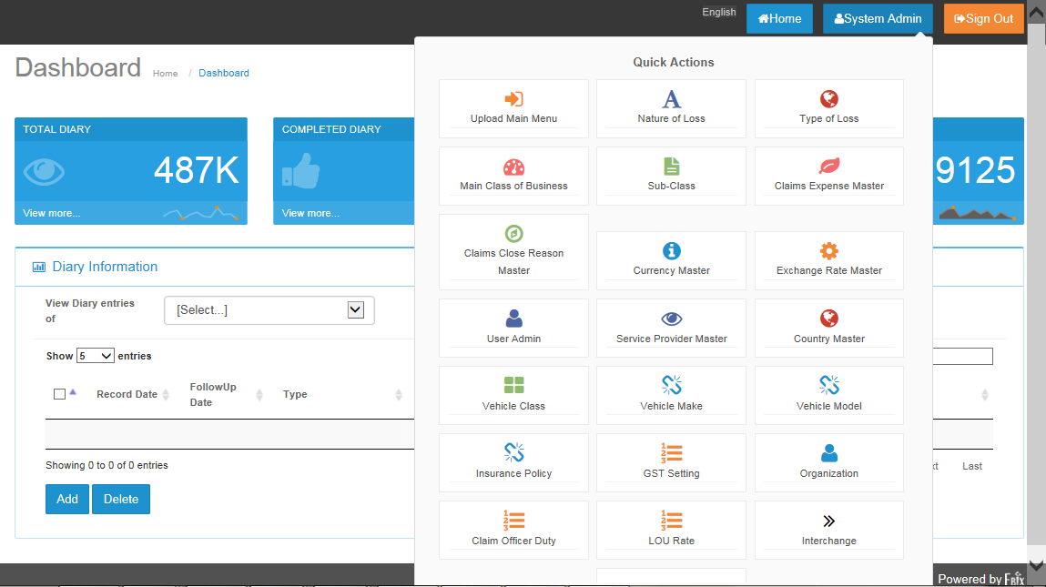

* Click on  to see Master list.

# Upload Main Menu

## Search screen



* Vehicle listing upload screen will appear by default.
* User can search either filling values on any of the text box
* After click on Search button user will get results.

## Search Result screen

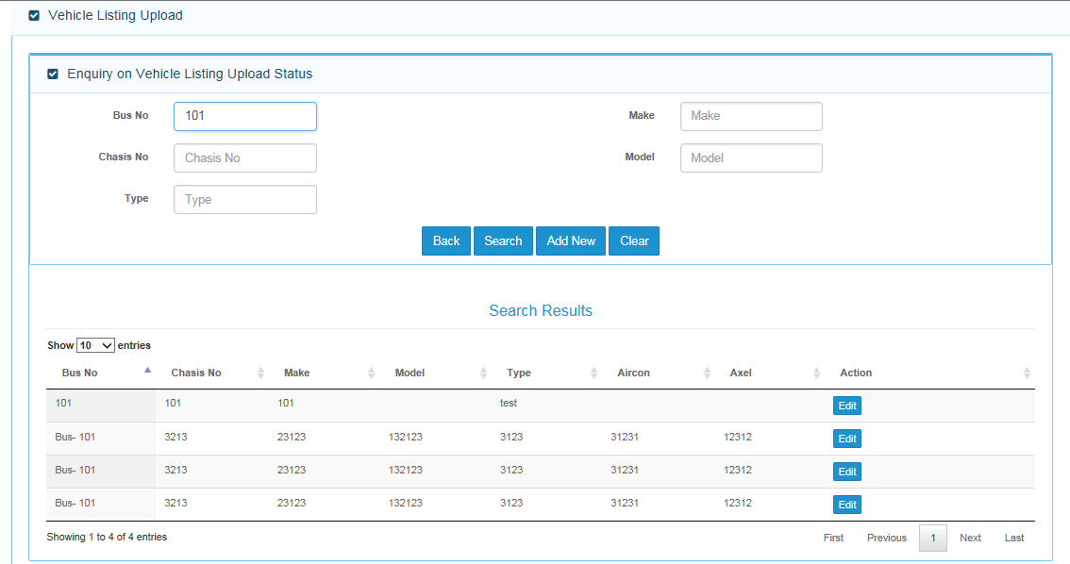

* After Click on edit button , Below screen will appear for editing any existing record.

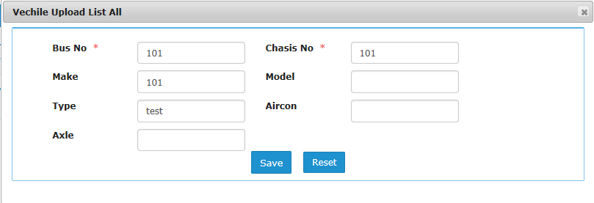

* User can enter new values and click on save button to edit any record.
* Field Validation :

|  |  |  |
| --- | --- | --- |
| **S.No.** | **Field Name** | **Validation** |
| 1. | Bus No. | Alphanumeric Value, Infinite Length |
| 2. | Make | Alphanumeric Value, Infinite Length |
| 3. | Chasis No. | Alphanumeric Value, Infinite Length |
| 4. | Model | Alphanumeric Value, Infinite Length |
| 5. | Type | Alphanumeric Value, Infinite Length |
| 6. | Aircon | Alphanumeric Value, Infinite Length |
| 7. | Axle | Alphanumeric Value, Infinite Length |

## Upload Section

* Below Search result screen, Upload section screen is located at the bottom of screen.

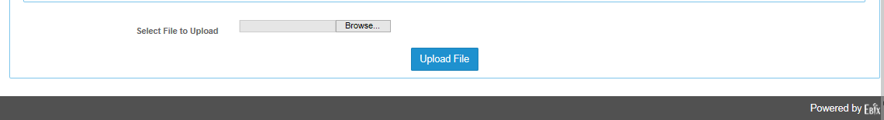

* Click on Browse button to search file to be uploaded.
* Click on Upload File button to start upload process.

### Field Validation

* Excel file needs to be inserted
* File must have 6 columns
* File with blank records , will not be allowed for insertion
* Duplicate file cannot be uploaded.

### Dependencies

* No Dependencies on file upload operation

### Message Handling

* If user does not select any file and click on Upload File. The below error message will appear.



### Outcome

* Record will be saved in database and shown in search result grid as following.

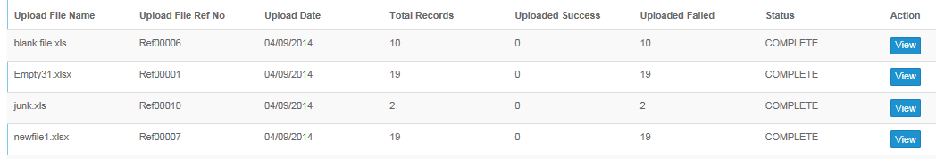

## Bus Captain Listing Screen

* Click search button to search existing record.
* Click Add new button to add bus captain record.
* Click Edit button to edit selected record.
* Click view button to view selected record.

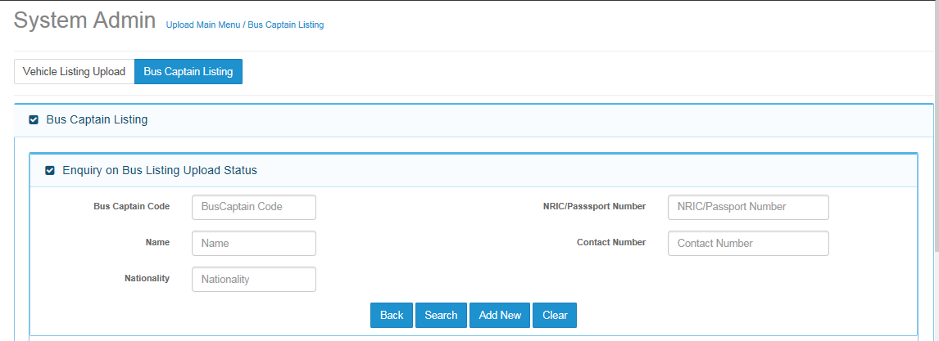

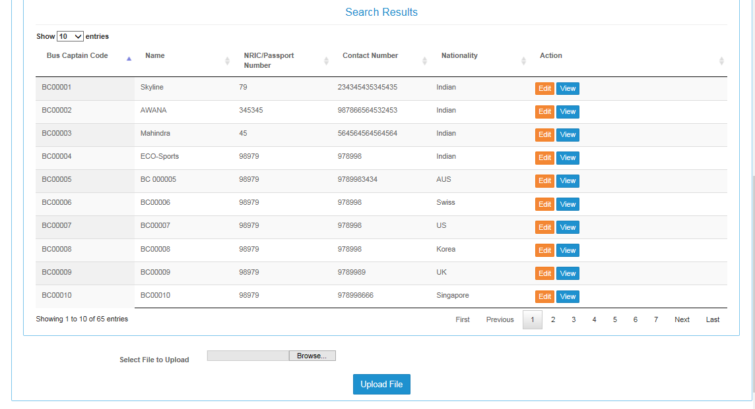

### Add Screen

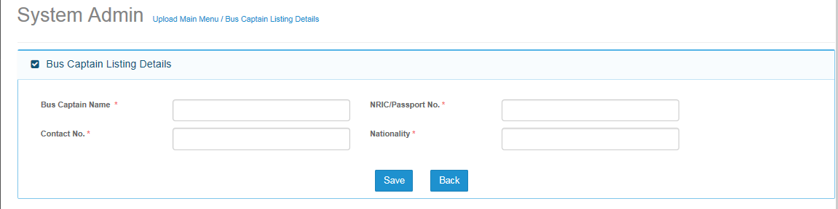

#### Screen Description

* Add screen will be used to add bus captain information.

#### Field Validations

#### Dependencies

* Not Applicable

#### Outcome

* Record will be saved in database.
* Record will appear in search screen

#### Messages Handling

* Below error message will appear, if user not enters bus captain code and direct click on save button.



# Type of Loss

* Please mention description of business use of type of loss.

## Search Screen

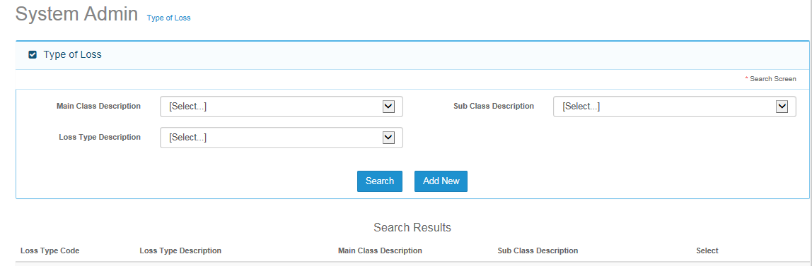

### Description

* Search screen will be first screen, when user clicks on type of loss menu.
* User can search record by entering one of three given fields.
* User need to first fill search criteria and then click on search button.
* Record will be displayed in search result section as per value filled in the search criteria.

### Field Validations

### Dependencies

* No Dependencies of search screen with any other screen.

### Outcome



* Record will be displayed after clicking on search screen.

### Message Handling

* All fields in search criteria are drop down list, so there will be no error message while selecting any value.

## Add Screen

### Field Validations

### Dependencies

* Values needs to be saved in Main Class master.
* Values needs to be saved in Sub class master.

### Outcome

* Record will be saved in database.
* Saved record will be displayed in search result section.

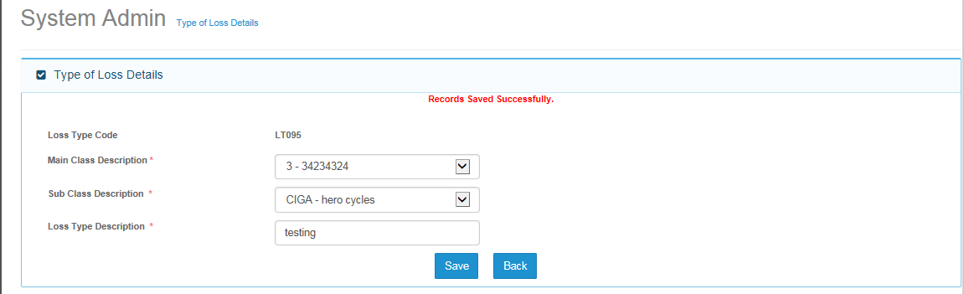

### Message Handling

* Validation message will appear, if user will click on save button without entering/selecting any value.

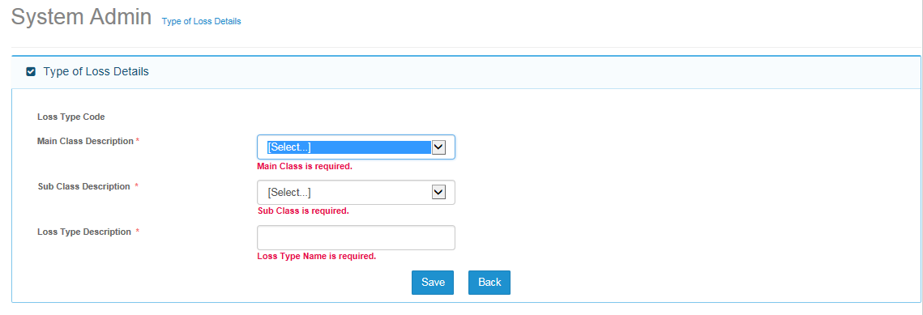

## Edit Screen

### Description

* To edit any existing record, user can search a particular record and then click on edit button to make changes in the record.

### Dependencies

* Records must be saved in the database, and then only it can be edited.

### Outcome

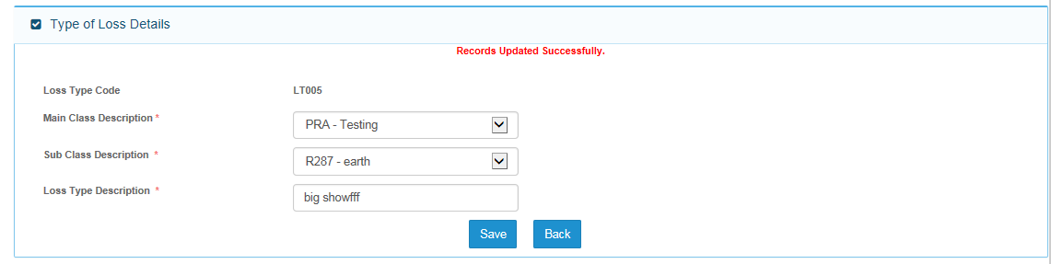

## View Screen

Note:

On View Screen, Save button will be hide and user will not be able to save any record.

# Main Class of Business

## Search Screen

### Description

* Based on Main Class description field, records can be searched.

### Field Validations

### Dependencies

* Main Class Description is a drop down list, only existing record will be displayed in the drop down list.

### Outcome

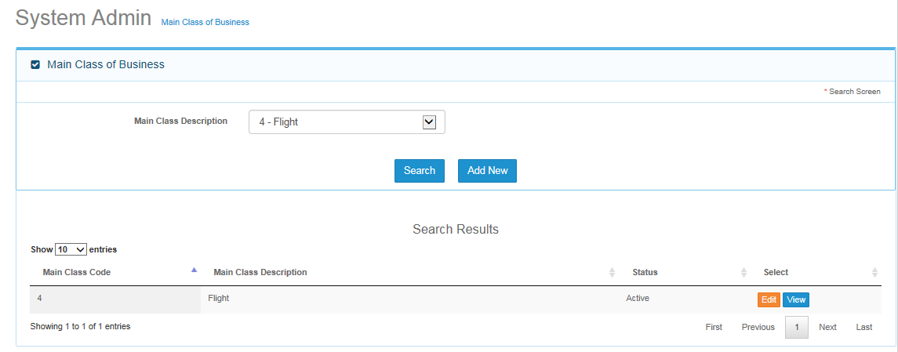

* Record will be displayed based on search criteria.

### Message Handling

* Not Applicable.

## Add Screen

### Description

* Please provide functional information of main class.

### Field Validations

### Dependencies

* Not Applicable.

### Outcome

* Record will be saved and below screen will be displayed.

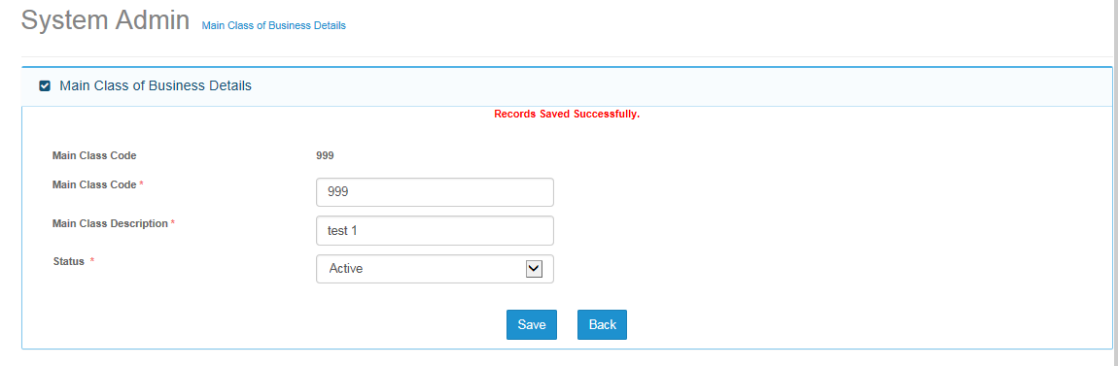

### Message Handling

* If user enters any existing main class code then below error message screen will appear.

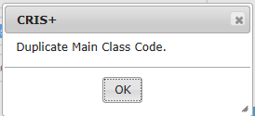

* If user click on save button without entering any values then below validation messages will appear.

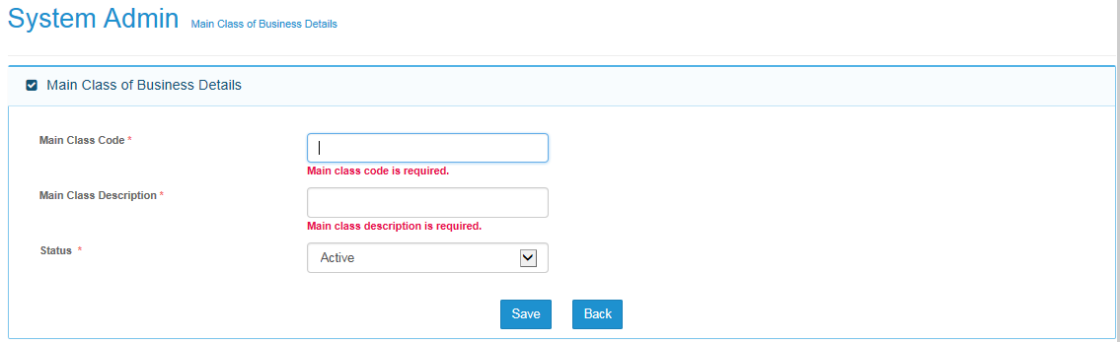

## Edit Screen

* Data elements of edit screen will saved as per add screen.
* User need to follow same validation as per add screen.

# Sub-Class

## Search Screen

### Description

* Sub class search screen.

### Field Validations

### Dependencies

### Outcome

### Message Handling

## Add Screen

### Description

### Field Validations

### Dependencies

### Outcome

### Message Handling

## Edit Screen

### Description

### Field Validations

### Dependencies

### Outcome

### Message Handling

# Claim expense master

## Search Screen

### Description

### Field Validations

### Dependencies

### Outcome

### Message Handling

## Add Screen

### Description

### Field Validations

### Dependencies

### Outcome

### Message Handling

## Edit Screen

### Description

### Field Validations

### Dependencies

### Outcome

### Message Handling

# Claim Close Reason Master

## Search Screen

### Description

### Field Validations

### Dependencies

### Outcome

### Message Handling

## Add Screen

### Description

### Field Validations

### Dependencies

### Outcome

### Message Handling

## Edit Screen

### Description

### Field Validations

### Dependencies

### Outcome

### Message Handling

# Currency Master

## Search Screen

### Description

### Field Validations

### Dependencies

### Outcome

### Message Handling

## Add Screen

### Description

### Field Validations

### Dependencies

### Outcome

### Message Handling

## Edit Screen

### Description

### Field Validations

### Dependencies

### Outcome

### Message Handling

# Exchange Rate Master

## Search Screen

### Description

### Field Validations

### Dependencies

### Outcome

### Message Handling

## Add Screen

### Description

### Field Validations

### Dependencies

### Outcome

### Message Handling

## Edit Screen

### Description

### Field Validations

### Dependencies

### Outcome

### Message Handling

# User Admin

## Entity Details

## Search Screen

#### Description

#### Field Validations

#### Dependencies

#### Outcome

#### Message Handling

## Add Screen

#### Description

#### Field Validations

#### Dependencies

#### Outcome

#### Message Handling

## Edit Screen

#### Description

#### Field Validations

#### Dependencies

#### Outcome

#### Message Handling

## User Group

## Search Screen

#### Description

#### Field Validations

#### Dependencies

#### Outcome

#### Message Handling

## Add Screen

#### Description

#### Field Validations

#### Dependencies

#### Outcome

#### Message Handling

### Edit Screen

#### Description

#### Field Validations

#### Dependencies

#### Outcome

#### Message Handling

### Select Permission List Screen

#### Description

#### Field Validations

#### Dependencies

#### Outcome

#### Message Handling

## User Screen

## Search Screen

#### Description

#### Field Validations

#### Dependencies

#### Outcome

#### Message Handling

## Add Screen

#### Description

#### Field Validations

#### Dependencies

#### Outcome

#### Message Handling

## Edit Screen

#### Description

#### Field Validations

#### Dependencies

#### Outcome

#### Message Handling

### Organization Access

#### Description

#### Field Validations

#### Dependencies

#### Outcome

#### Message Handling

### FAL Access to User

#### Description

#### Field Validations

#### Dependencies

#### Outcome

#### Message Handling

## Department master

## Search Screen

#### Description

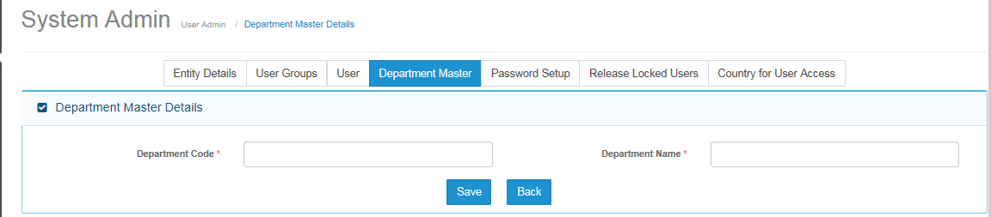

#### Field Validations

#### Dependencies

#### Outcome

#### Message Handling

## Add Screen

#### Description

#### Field Validations

#### Dependencies

#### Outcome

#### Message Handling

## Edit Screen

#### Description

#### Field Validations

#### Dependencies

#### Outcome

#### Message Handling

## Password Setup

## Main Screen

#### Description

#### Field Validations

#### Dependencies

#### Outcome

#### Message Handling

## Released Locked User

* Requirement Pending

## Country For User Access

* Requirement Pending

# Country Master

## Search Screen

### Description

### Field Validations

### Dependencies

### Outcome

### Message Handling

## Add Screen

### Description

### Field Validations

### Dependencies

### Outcome

### Message Handling

## Edit Screen

### Description

### Field Validations

### Dependencies

### Outcome

### Message Handling

# Vehicle Class

## Search Screen

### Description

### Field Validations

### Dependencies

### Outcome

### Message Handling

## Add Screen

### Description

### Field Validations

### Dependencies

### Outcome

### Message Handling

## Edit Screen

### Description

### Field Validations

### Dependencies

### Outcome

### Message Handling

# Vehicle Make

## Search Screen

### Description

### Field Validations

### Dependencies

### Outcome

### Message Handling

## Add Screen

### Description

### Field Validations

### Dependencies

### Outcome

### Message Handling

## Edit Screen

### Description

### Field Validations

### Dependencies

### Outcome

### Message Handling

# Vehicle Model

## Search Screen

### Description

### Field Validations

### Dependencies

### Outcome

### Message Handling

## Add Screen

### Description

### Field Validations

### Dependencies

### Outcome

### Message Handling

## Edit Screen

### Description

### Field Validations

### Dependencies

### Outcome

### Message Handling

# Insurance Policy

## Search Screen

### Description

### Field Validations

### Dependencies

### Outcome

### Message Handling

## Add Screen

### Description

### Field Validations

### Dependencies

### Outcome

### Message Handling

## Edit Screen

### Description

### Field Validations

### Dependencies

### Outcome

### Message Handling

# GST Setting

## Search Screen

### Description

### Field Validations

### Dependencies

### Outcome

### Message Handling

## Add Screen

### Description

### Field Validations

### Dependencies

### Outcome

### Message Handling

## Edit Screen

### Description

### Field Validations

### Dependencies

### Outcome

### Message Handling

# Organization

## Search Screen

### Description

### Field Validations

### Dependencies

### Outcome

### Message Handling

## Add Screen

### Description

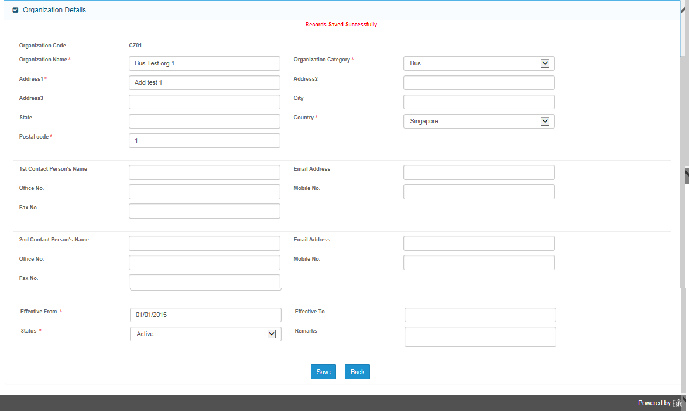

### Field Validations

### Dependencies

### Outcome

### Message Handling

## Edit Screen

### Description

### Field Validations

### Dependencies

### Outcome

### Message Handling

# Claim Officer Duty

## Search Screen

### Description

### Field Validations

### Dependencies

### Outcome

### Message Handling

## Add Screen

### Description

### Field Validations

### Dependencies

### Outcome

### Message Handling

## Edit Screen

### Description

### Field Validations

### Dependencies

### Outcome

### Message Handling

# LOU Rate

## Search Screen

### Description

### Field Validations

### Dependencies

### Outcome

### Message Handling

## Add Screen

### Description

### Field Validations

### Dependencies

### Outcome

### Message Handling

## Edit Screen

### Description

### Field Validations

### Dependencies

### Outcome

### Message Handling

# Service Provider Master

## Insurer Master

## Search Screen

#### Description

#### Field Validations

#### Dependencies

#### Outcome

#### Message Handling

## Add Screen

#### Description

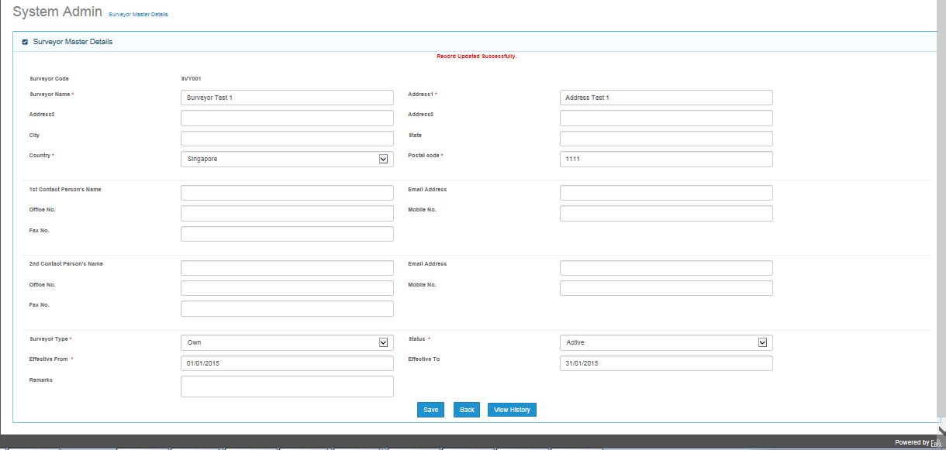

#### Field Validations

#### Dependencies

#### Outcome

#### Message Handling

## Edit Screen

#### Description

#### Field Validations

#### Dependencies

#### Outcome

#### Message Handling

## Surveyor Master

## Search Screen

#### Description

#### Field Validations

#### Dependencies

#### Outcome

#### Message Handling

## Add Screen

#### Description

#### Field Validations

#### Dependencies

#### Outcome

#### Message Handling

### Edit Screen

#### Description

#### Field Validations

#### Dependencies

#### Outcome

#### Message Handling

## Lawyer Master Screen

## Search Screen

#### Description

#### Field Validations

#### Dependencies

#### Outcome

#### Message Handling

## Add Screen

#### Description

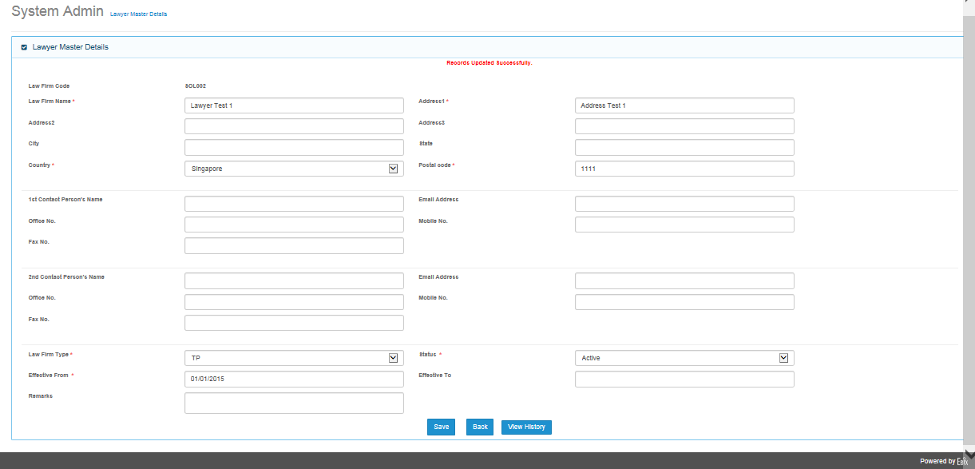

#### Field Validations

#### Dependencies

#### Outcome

#### Message Handling

## Edit Screen

#### Description

#### Field Validations

#### Dependencies

#### Outcome

#### Message Handling

## Workshop/Depot Master

## Search Screen

#### Description

#### Field Validations

#### Dependencies

#### Outcome

#### Message Handling

## Add Screen

#### Description

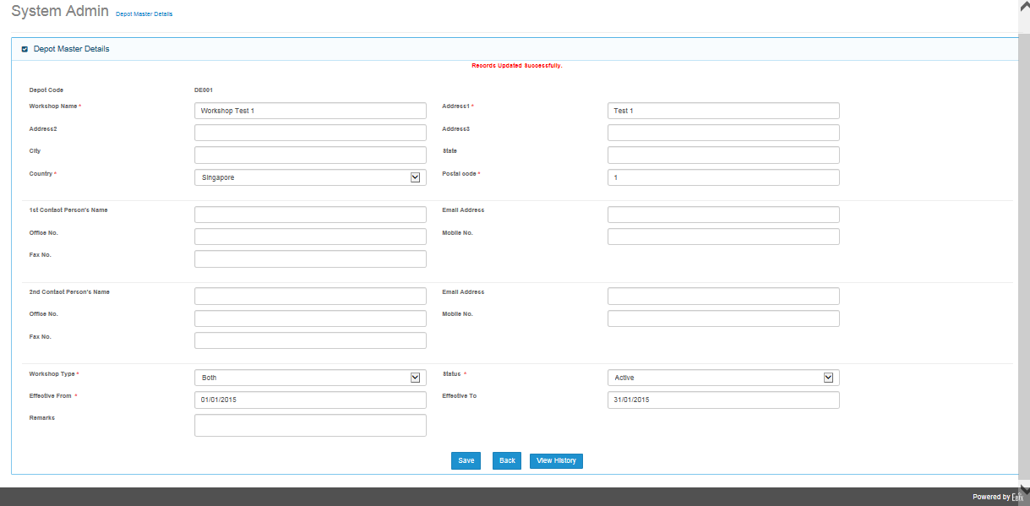

#### Field Validations

#### Dependencies

#### Outcome

#### Message Handling

## Edit Screen

#### Description

#### Field Validations

#### Dependencies

#### Outcome

#### Message Handling

## Hospital Master

## Search Screen

#### Description

#### Field Validations

#### Dependencies

#### Outcome

#### Message Handling

## Add Screen

#### Description

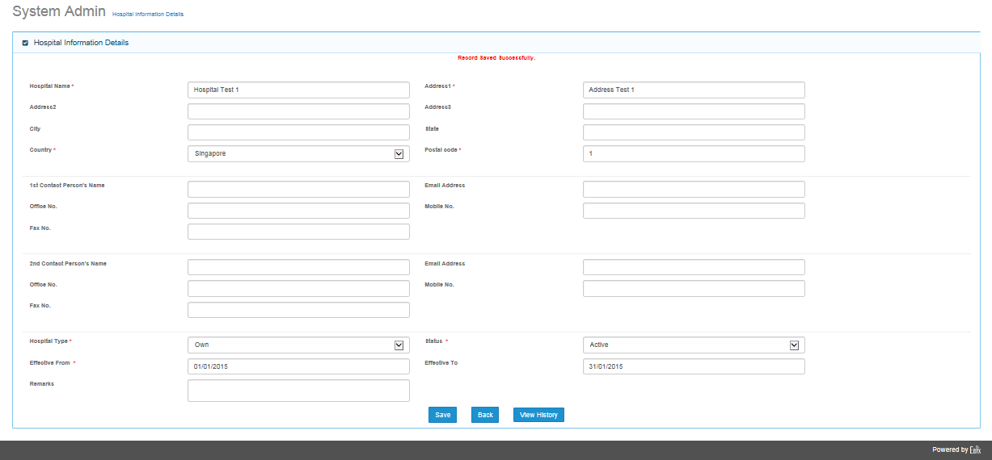

#### Field Validations

#### Dependencies

#### Outcome

#### Message Handling

## Edit Screen

#### Description

#### Field Validations

#### Dependencies

#### Outcome

#### Message Handling

## Adjuster Master

## Search Screen

#### Description

#### Field Validations

#### Dependencies

#### Outcome

#### Message Handling

## Add Screen

#### Description

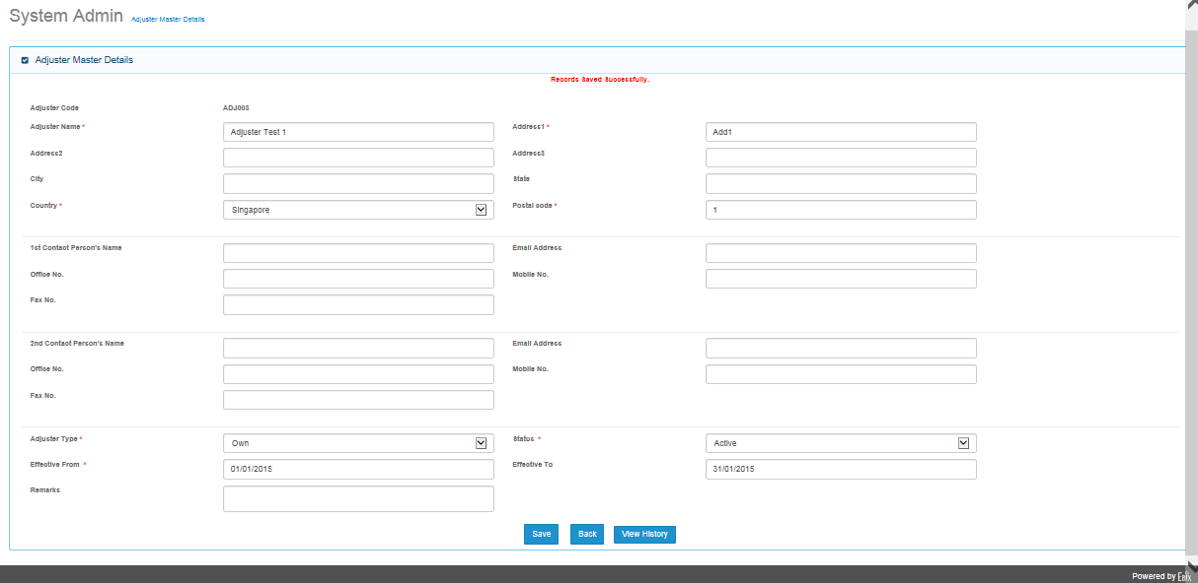

#### Field Validations

#### Dependencies

#### Outcome

#### Message Handling

## Edit Screen

#### Description

#### Field Validations

#### Dependencies

#### Outcome

#### Message Handling

# Interchange Master Screen

## Search Screen

### Description

### Field Validations

### Dependencies

### Outcome

### Message Handling

## Add Screen

### Description

### Field Validations

### Dependencies

### Outcome

### Message Handling

## Edit Screen

### Description

### Field Validations

### Dependencies

### Outcome

### Message Handling

# Deductible Master

## Search Screen

### Description

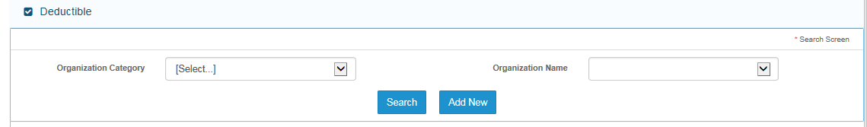

### Field Validations

|  |  |  |
| --- | --- | --- |
| S..no. | Field name | Validation |
| 1 | Organization Category | Drop down list , not applicable |
| 2 | Organization Name | Drop Down List, Not Applicable |

### Dependencies

### Outcome

### Message Handling

## Add Screen

### Description

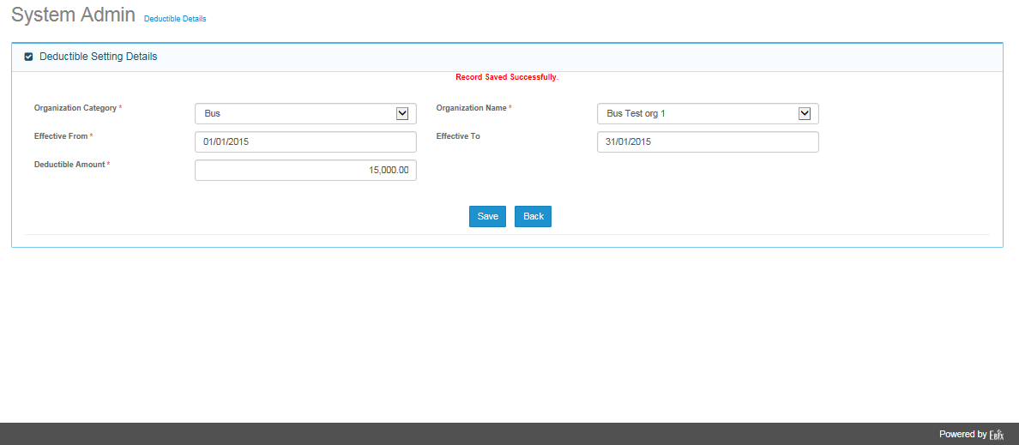

### Field Validations

### Dependencies

### Outcome

### Message Handling

## Edit Screen

### Description

### Field Validations

### Dependencies

### Outcome

### Message Handling